**The “How to” for Tournament Play**

Every Tournament Has 3 Phases

* Pairings
* Playing
* Post Game

**The way you sign up for tournaments is pretty much comes down to Emailing or Talking directly to Matt S our Club Tourney Organiser**

**Common Questions**

**Q:can I take byes**

**A: yes just ask sooner than later and of course not during pairings**

**Q:Phones?**

**A:Just keep them off so we don’t have disturbances or Cheating**

**Q:do I have to pay for FCC tournaments**

**A: No the usual vistor/member payments cover this as a club**

# Pairings

Pairings is when everyone groups before round for roll call and pairing the players through tornelo (tornelo is a pairing site) and then is announced all pairings are announced at the start of the round

Just be on Time or you will receive a Bye point if available

Be Quiet while we call out the pairings or roll call

# Playing

The fun part here’s a rundown of how it works.

* You find the opponent you got paired with or if there’s table numbers follow them.
* You sit-down and wait for the Arbiter to say “start your clocks” as to leave time for arbiter to announce anything
* Black starts the clock for white usually a middle central button on the clock but we have multiple designs so if troubled ask arbiter

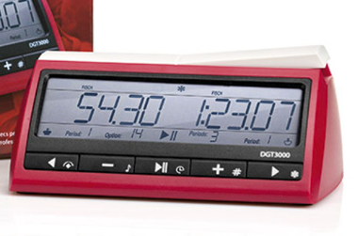far left and 2nd far right buttons switch between time modes the far right button confirms mode where on the screen the middle button symbol shows in which you can press the centre button

Now Important things that Can not be Expressed Enough

* **TOUCH MOVE (if you touch a piece you move it unless you mention adjust as you steady the pieces on a square if offside)**
* **2 ILLEGAL MOVES IS FORFEIT( 1 MOVE IS POSSIBLE TIME BOOST FOR OPPONENT if claimed)**
* **FLAG CLAIM (if a player flags but the players nor arbiter notices then game plays on till someone notices)**
* **ONLY THE ARBITER CAN CALL OUT THESE THINGS OR THE PLAYERS THEMSELVES SPECTATORS CANT CALL OUT RULES ON BOARDS NO MATTER THE OBVIOUSNESS**

Offering a Draw

Offering a draw has to be done on your move and AFTER you make your move you say “Draw” in which the opponent can decide till he makes his move

# Post Game

This part is mainly how you treat the playing hall after your game

* Once hands have shaken a whisper or two saying good game is fine but PLEASE keep all analysis outside the tournament room (Unless your last board)
* Turn off clocks so we don’t have flag noises going off or reset them
* If last round of the day quietly pack up the board and have it ready to pick up from the table

Most Times we have around 5 to 15min breaks between rounds so feel free to play casual chess in the Casual Area of the club while waiting in which a bell will be rung for new round

Results are on Tornelo that’s available through frankstonchessclub.com